**THE LOGISTIC FUNCTION**

**Exponential Functions**

Consider the functions below:

Unbounded exponential functions:

  

  

Bounded exponential function:

 

 but  seems to be bounded.

Use limits to find the upper limit.

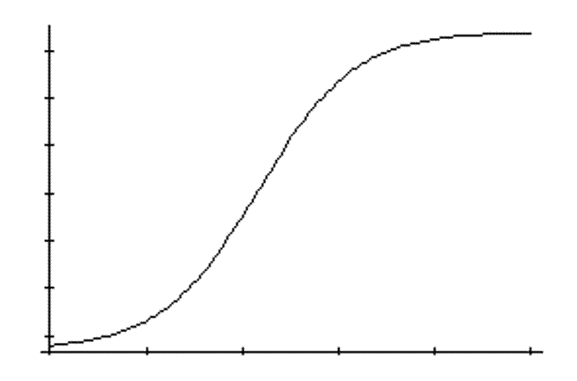The logistic function models a population that has a maximum carrying capacity. For example, If a number of rabbits are placed on an island, they thrive and populate until they reach the population that is sustainable by the amount of food available on the island. Likewise, if the number of rabbits put on the island exceeds the carrying capacity of the island, the population decreases until the population becomes stable given the food supply.

The number of bacteria in a petri dish doubles every few minutes. This is exponential growth, but the growth cannot continue indefinitely. The rate of increase slows as the dish “fills”.

**INVESTIGATING** **Exponential Functions**

1. Consider the following functions

(a) 

Determine the limit as , and as  . Sketch the graph.



(b) 

Determine the limit as , and as  . Sketch the graph. 

2. Sketch the following graphs

(a) 

(b) 

(c) 

3. Experiment with the sketch the function  for b = 1, 10, 20, 40, 100, 1000.

Comment on the effect of changing the value of b.

Comment on the effect of changing the 200.

Consider the graphs you have drawn but using the domain x > 0.

Which of them models the graph below? What does this imply about b?

[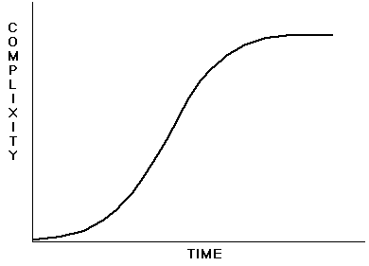](http://www.google.com.au/url?sa=i&rct=j&q=&esrc=s&source=images&cd=&cad=rja&uact=8&ved=0CAcQjRxqFQoTCMuD-_rD8MYCFUPHpgodz8cBzg&url=http://asweknowit.ca/evcult/Arena/Arena00.shtml&ei=AH2wVcuDFsOOmwXPj4fwDA&psig=AFQjCNHc6qUAiTsk7Gts4rI1VkDSQg-CPg&ust=1437716003259223)

4. Experiment with the sketch the function  for k = 1, 2, 5.

Comment on the effect of changing the value of k.

5. Show that the function  can be expressed in the form .

6. Given , determine 

Sketch the function.

Investigate the function for different values of .

**THE LOGISTIC FUNCTION**

The logistic equation is in the form where 

 where  has the graph

NB y(0)= 

and as 



At the beginning, the population increases, at an increasing rate.

The gradient of the curve is always positive.

As the population approaches the carrying capacity, the population still increases, but at a decreasing rate.

NB

The gradient function can been seen to be of the form

 

Since the logistic equation has an increasing component and a decreasing component we use

 where *P* is the population and *K* is the carrying capacity.

Assuming the initial population is less than the **carrying capacity** we have 

The **carrying capacity** of a biological species in an environment is the maximum population size of the species that the environment can sustain indefinitely, given the food, habitat, water, and other necessities available in the environment.

*P* increases as 



Investigate the values of  at *P* close to *P0*, *P* close to *K* and *P* greater than *K*. Assume 

At



Sketch the derivative function:



**To find the logistic function from the derivative function:**



Reciprocate both sides

Using partial fractions

where 

after multiplying by 



where *K* is the carrying capacity, *t* is the time and *A* and *r* are constants.

At *t* = 0, 



Logistic growth can be modelled by the equation  where *P0* is the initial population, and *K* is the carrying capacity, and *r* a constant related to the rate of growth.

**EXAMPLES**

1. (a) Plot the following function  on your calculator to confirm it has the S

shape expected of the logistic function.

(b) Find an expression for  to confirm slope of the function  is always positive.

(c) Use the expression  to determine the limiting value of  as 

**Solution:**

1. (a)



(b) 



Therefore the slope is always increasing.

(c) 

2. A fish farmer stocks a large pond with 800 fish. He estimated that the carrying capacity of

the pond is about 9,000 fish. From experience he expects that that the fish population

will double during the first year.

(a) Use the logistic equation to determine an expression for the fish population after *t*

years.

(b) How long will it take the fish population to reach 6000?

**Solution:**

(a) Using  where *P* is the population of fish at time *t*, *r* is the constant related to the rate of growth and Kis the carrying capacity, we have



At the end of the first year, the number of fish will have doubled. i.e. 

We can now solve for *r*.



Therefore we have



(b) Find  for = 6000.

If using Solve on the calculator. You may find it quicker to rearrange the equation so that there is no denominator (to avoid the calculator freezing).



i.e. three years 9.5 months for the population of fish to reach 6000.

3. In a small village of 2 000 people, a new and dangerous flu is spreading slowly.

Today, 5 people have been diagnosed with the flu.

The rate of number of people catching the flu is given by  where *N* represents the number of people with the flu and *t* represents weeks.

(a) Find an expression for the number of people infected.

(b) Determine the expected number of people to be infected in 5 weeks time.

(c) Determine how many weeks it will take for the number of infected people to double.

**Solution**

[](http://2.bp.blogspot.com/-pj-PtDh3v60/UQse8jRtTyI/AAAAAAAAACk/Vtbz-u_a64g/s1600/animated+picture+of+a+person+with+the+flu.jpg)(a) 



Using partial fractions,

<http://summaryonarticle.blogspot.com.au/2013/01/mount-sinai-researchers-discover-how.html>





Rearrange the formula to get *N*=



At 



(b) In five weeks time, *t = 5, N = ?*



i.e. in 5 weeks time, expect 8 people to have the flu.

(c) If 



The number of people with the flu will double in about 7 weeks.

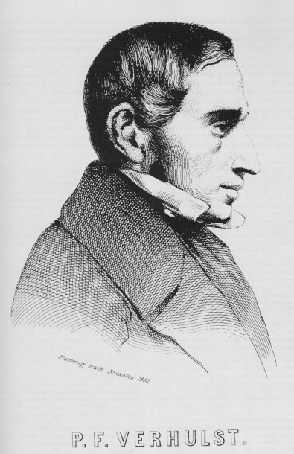

Verhulst published in 1838 the equation:

 \frac{dN}{dt} = r N \left(1 - \frac {N}{K} \right)

when *N*(*t*) represents number of individuals at time *t*, *r* the intrinsic growth rate and *K* is the carrying capacity, or the maximum number of individuals that the environment can support.

In a paper published in 1845 he called the solution to this the logistic function.

This model was rediscovered in 1920 by Raymond Pearl and Lowell Reed, who promoted its use.

<https://en.wikipedia.org/wiki/Pierre_Fran%C3%A7ois_Verhulst>

<http://wmueller.com/precalculus/families/1_80.html>

<http://wmueller.com/precalculus/families/1_80.html>

**Solutions to the investigation**

1. (a) 





(b) 





2. (a) 





(b) 





(c) 





3.  b = 1, 10, 20, 40

b = 1



b = 10



b = 20



b = 40



b = 100



b = 1000



As b increases, the graph moves to the right.

The 200 is the stretch factor with respect to the y axis.

With b = 1000, the model is like the logistic function for x > 0.

b =1 b =10 b =20 b = 40 b = 100 b = 1000

 

For b = 1000 the graph mostly resembles the logistic function.

If b is large compared to the value of 20 in the denominator, the graph resembles the logistic function for x > 0.

4. Experiment with the sketch the function  for k = 1, 2, 5, 0.1, 0.001.

Comment on the effect of changing the value of k.

k = 1



k = 2



k = 5



As k increases, the upper limit is reached at a faster rate.

5. Show that the function  can be expressed in the form .



6. Given ,





As b decreases, the graph translates to the left.

a and b need to be examined together.

c is the vertical multiplying factor.